**CARELINK PERSONAL WORKSHEET for 780G + Linked CGM (Smart Guard)**

Dates of Download: ____________ to ____________

**Assessment and Progress Report**

Statistics

* Sensor wear percentage: ________ (aim: >85% = 6 days + wear)



* Percent time in SmartGuard: ________ (aim: > 80%)
* Percent time in Manual Mode: _______ (aim: <5%)

(Refer to ‘weekly reviews for more details on exit reasons to manual mode)

* GMI (Hba1c Predictor from last 14 days): _______ mmol/mol
* Average BG ____________ (aim: less than 8mmol/L)



* Time in Range (3.9 – 10) __________ (aim: >70%)
* Time in Range (<3.9) ____________ (aim: < 5%)
* BG/Calibration (per day): _________(aim: 2/2 – minimum calibration is 2 in 24hrs)
* Total Daily Insulin ___________ (this is the average total daily dose)

**Calculate insulin sensitivity i.e. 100 ÷ Total Daily Insulin**



* Calculated Insulin Sensitivity = ______ (Important for manual mode settings)
* Bolus Amount _______ % (usually 60-70%)
* Auto Basal Amount _______ units (this is the total background insulin)

**Weekly Review**

* Useful as a quick reference to weekly ‘SmartGuard’ exits at a glance and reasons why.
* E.G. ? Discussion points If prolonged exit event (evident in a shaded black block with a number above which correlates with exit reasons)

**Adherence Report**

From the summary at the bottom of the page:

* BG readings _________
* Bolus wizard events ____ ____ (aim: at least 6 per day)
* Rewind: Every _________ days (this indicates set changes, aim: every 2-3 days)

**NB** Site Rotation – Regular rotation of sites for set changes are crucial

* Cannula amount __________(Mio 6mm = 0.3 units / Mio 9mm = 0.5 units / Mio 30/Silhouette = 0.7 units / Mio Advance = 0.6 units / Sure T = 0 units)

**DEVICE SETTINGS SNAPSHOT**

**Point to Remember:**

SmartGuard only **4 key changes** can be made to Device Settings –

* **Active Insulin**
* **Target (5.5/6.1/6.7)**
* **Auto Correction (On/Off)**
* **Carb Ratio**

Bolus: Active insulin time ____________ (usually 3hrs)

**NOTE:**

* **IF micro basals excessive causing hypos, consider extending by 0.5 - 1 hour (more apparent with trends overnight or not related to bolus)**
* **Persistent lows after Auto Corrections – consider extending Active Insulin Time to avoid**

SmartGuard: Target _______ mmol/L

**NOTE:**

* **Persistent lows without bolus: consider higher target**
* **Persistent higher without bolus: consider lower target (ensure no increase in alarms due to this change)**

SmartGuard: Auto Correction defaults to ‘on’ (correct back to SG 6.7 mmol/L)

**(Auto Correction can occur every 5 mins if smart guard determines correction is necessary)**

**NOTE:**

* Overnight low levels or hypo occurrence - Option to switch off Auto Corrections (Smart Guard Settings) IF felt due to auto corrections and auto basal combo encouraging lower levels)
* Option to also use ‘Temp Target’ for overnight to temp switch of Auto Correction but raise Target to Auto Basal back to 8.3 mmols.

Carbohydrate Ratio (g/U): **RELEVANT FOR AUTO MODE AND MANUAL MODE:**

**NOTE (timing of bolus pre meal still important):**

* **High 2hrs post bolus** – consider alterations to ratio :
  + Awareness that **micro basal pulses higher + Auto Corrections if bolus insulin not enough** which can cause delayed low within 2-3hrs – aim to resolve this with ratio change 1st instance to eliminate high excursion.
* **Low 2hrs post bolus** – consider alterations to ratios

|  |  |  |  |
| --- | --- | --- | --- |
| Time | Current Ratio | Insert usual meal/ snack eaten at this time | Proposed ratio change |
|  |  |  |  |
|  |  |  |  |
|  |  |  |  |
|  |  |  |  |
|  |  |  |  |

**DEVICE SETTINGS SNAPSHOT**

Suspend on/before low set at: _______ (Usual set between 3.4 – 3.6)

* Adjust lower (down to 3.0) if family suffering Alarm Fatigue – informed discussion around normalising hypo excursions between 3.5 – 3.9 (in particular overnight)
* Option to silence alarms overnight only – Audio Options – Alert Silence Options – High and Low Alerts and Duration set then save.
  + Reassure that the system will override silence alarm if detect Sensor Glucose to hit 2.8 mmols/mol

Note:

* If exit into Manual Mode occurs – the Low Management Feature Suspend before and on low will automatically be turned on again by system

Temp Target Setting (changes micro basal value from set target up to 8.3)

Use: Exercise Management or overnight

* Main icon menu – select the shield - select Temp Target – select duration (set between 2 – 12hrs) – Start

**Insulin Sensitivity**

In Auto Mode the sensitivity is calculated based on active insulin at the time of correction and TDD 6 day history **-** The system can Auto Correct if mode switched on, therefore It will rarely ask for a correction unless detected it needs additional support

THIS IS ONLY RELEVANT TO MANUAL MODE –

* if in manual mode and can see not working, adjust accordingly
* If mainly in auto mode and set sensitivity is very different from calculate considering adjusting to midpoint between these two numbers

100 Rule Calculation: 100 / TDD = _______

Device Settings: _______ NEW Setting: _________

**REVIEW MANUAL MODE SETTINGS**

Basal: (active) will be beside basal rate **being used when in Manual Mode**

* Max Basal _______units/hr (Check highest basal rate and max set at 50% more only if altering manual basal rate settings)

**Basal Rate Settings for Manual Mode Review:**

* **Auto Mode (AM) Basal Units: ______**
* **Manual Settings Basal Units: ______­**
* **Refer to Flow Chart:**

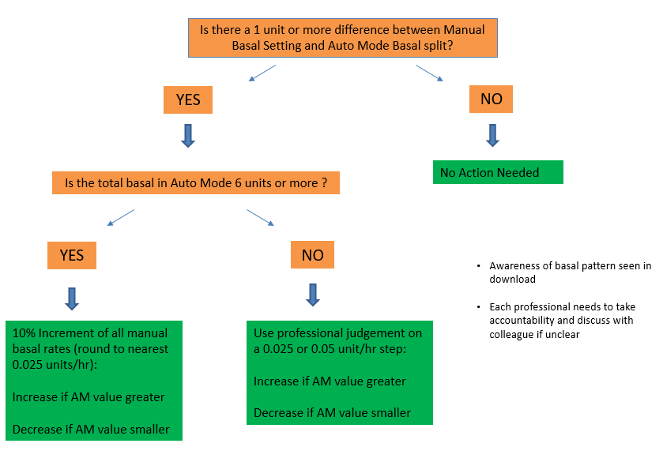

**Basal settings:**

|  |  |  |
| --- | --- | --- |
| **Time** | **Unit/hr (OLD)** | **Units/hr (NEW)** |
|  |  |  |
|  |  |  |
|  |  |  |
|  |  |  |
|  |  |  |

**ACTION PLAN and/or topics for discussion at clinic**

**Actions:**

**HOW TO MAKE CHANGES TO:**

**RATIOS:**

|  |  |  |  |  |  |
| --- | --- | --- | --- | --- | --- |
| **Trend of BG 2 hrs after the meal** | **Action needed** | **Suggested ratio change** | | | |
| **High**  (More than 9mmol/L) | Decrease the number of grams of carbs that 1 unit of insulin will cover | 1:2→1:1.5 | 1:7→1:6 | 1:15→1:12 | 1:30→1:25 |
| 1:3→1:2 | 1:8→1:7 | 1:18→1:15 | 1:35→1:30 |
| 1:4→1:3 | 1:9→1:8 | 1:20→1:18 | 1:40→1:35 |
| 1:5→1:4 | 1:10→1:9 | 1:22→1:20 | 1:45→1:40 |
| 1:6→1:5 | 1:12→1:10 | 1:25→1:22 | 1:50→1:45 |
|  |  |  |  |  |  |
| **Low**  (Lower than 4 mmol/L) | Increase the number of grams of carbs that 1 unit of insulin will cover | 1:1.5→1:2 | 1:6→1:7 | 1:12→1:15 | 1:25→1:30 |
| 1:2→1:3 | 1:7→1:8 | 1:15→1:18 | 1:30→1:35 |
| 1:3→1:4 | 1:8→1:9 | 1:18→1:20 | 1:35→1:40 |
| 1:4→1:5 | 1:9→1:10 | 1:20→1:22 | 1:40→1:45 |
| 1:5→1:6 | 1:10→1:12 | 1:22→1:25 | 1:45→1:50 |

* To make an adjustment to a ratio on the pump go into:

Settings (Cog Symbol) – Delivery Setting – Bolus Wizard Set up – Carb Ratio or Active Insulin

* To make adjustments to SmartGuard Settings:

SmartGuard Menu (Shield Symbol) – SmartGuard Settings – Target or Auto Correction on/off